How to Fix Your Credit Score

How scores are determined is often hidden and doesn’t treat all consumers equally. Here’s what to watch for, and what to do.
By Lisa L. Gill
June 10, 2021
Nine years ago, Brittnay Williams’ credit score was 569—putting her in the “very poor” category and undermining her dream of buying a home. But over the course of two years and with the help of her credit union, Williams, of West Memphis, Ark., raised her score by 100 points and qualified for a mortgage.
When she began her journey, Williams, 32, was among the estimated 14 percent of active credit consumers with credit scores so low it is hard to qualify for a mortgage, according to Experian, one of the big three credit bureaus. About 26 million adults lack any credit history and have no score at all, according to the most recent figures from the Consumer Financial Protection Bureau, a government agency.
“Millions of Americans are locked out of the American dream of homeownership, higher education, starting a business, or making major purchases,” says Syed Ejaz, financial policy analyst at Consumer Reports. “For most lenders, everything begins and ends with that score.”
Introduced in the 1950s, credit scores were intended to objectively measure creditworthiness, based on your history of borrowing and paying back loans. Two companies, FICO and VantageScore, create the scoring models, which apply formulas to information in your credit reports, for the three major credit reporting agencies—Experian, TransUnion, and Equifax—that track your past financial behavior. The higher the score, the more likely you’ll receive lower interest rates for a credit card, mortgage, or car loan.
MORE ON CREDIT SCORES
More Than a Third of Consumers Discovered Errors in Their Credit Reports, CR Study Finds
Why Mortgage Credit Scores Are Little Known and Often Low
How to Avoid Problems Rolling Over a Car Loan
How to Make Sense of Your (Dozens of) Credit Scores
A Broken System: How The Credit Reporting System Fails Consumers And What To Do About It
But not everything in your financial life counts toward your score. For example, paying rent on time often won’t help, but paying a mortgage on time will. The system usually also doesn’t care whether late payments stem from things out of your control—say, an illness—or your own irresponsibility. And it will punish you for years for a slip-up. Moreover, because it rewards people who already have a credit history—and makes it hard for those who don’t to establish credit—it creates a circular problem that limits options for many.
That’s particularly true for Blacks and Hispanics, who have substantially lower credit scores, on average, than whites, says Chi Chi Wu, staff attorney for the National Consumer Law Center, a nonprofit that works for consumer justice and economic security. For example, a 2019 analysis from the Urban Institute, a nonprofit research organization, found that more than 50 percent of white people had a FICO score greater than 700, while just 21 percent of Black people did.
“Having a weak credit record can hurt your chances for getting a job, because employers often check your credit report,” Wu says. And because landlords and insurers also often check credit reports, a poor score can “prevent you from renting an apartment, or mean you’ll pay more for car insurance,” she says.
Credit scores also suffer from a lack of transparency, some consumer advocates say. We all have many credit scores, each calculated differently, and it is hard to know which score a given lender uses, though knowing could help us build that score.
Worse, consumers can’t directly dispute a credit score, though the credit report data behind scores often have errors. Around a third of the almost 6,000 volunteers for a recent CR study found mistakes in their credit report.
For Williams, building credit had a lasting impact. Several years after buying her house and finding her financial footing, she opened a home healthcare business that she says now employs 60 people and serves more than 100 homebound seniors. “I am blessed to be able to do this work and get the help I did,” Williams says.
Here are some ways credit scores can undermine your financial future and 11 tips for fixing them.
The scoring system makes it hard for people who don’t have a credit history to even establish one.

Problem: Lack of Credit History = Low Score
It’s a credit Catch-22: You need credit to build credit, says Bill Hardekopf, a senior industry analyst at CardRates.com, a company that evaluates credit card offers. This can be a challenge in communities of color in particular, he says. The Urban Institute found that 32 percent of Black people vs. 18 percent of white people didn’t have enough information in their credit reports to generate a score.
One way to build history is to open a checking or savings account. But that can be easier said than done: A 2020 Morgan Stanley report on inequality in homeownership found that there is greater commercial “branch scarcity” in communities with diverse populations. Minimum deposit rules and high checking fees can be other deterrents.
Be aware that even if you have a credit history, it can become “stale” if you don’t continue to use credit regularly. “That’s because some of the scoring algorithms treat recent use of credit as a positive factor in calculating your score,” Hardekopf says. In some instances, credit card issuers can close inactive accounts, and your credit score can take a hit.
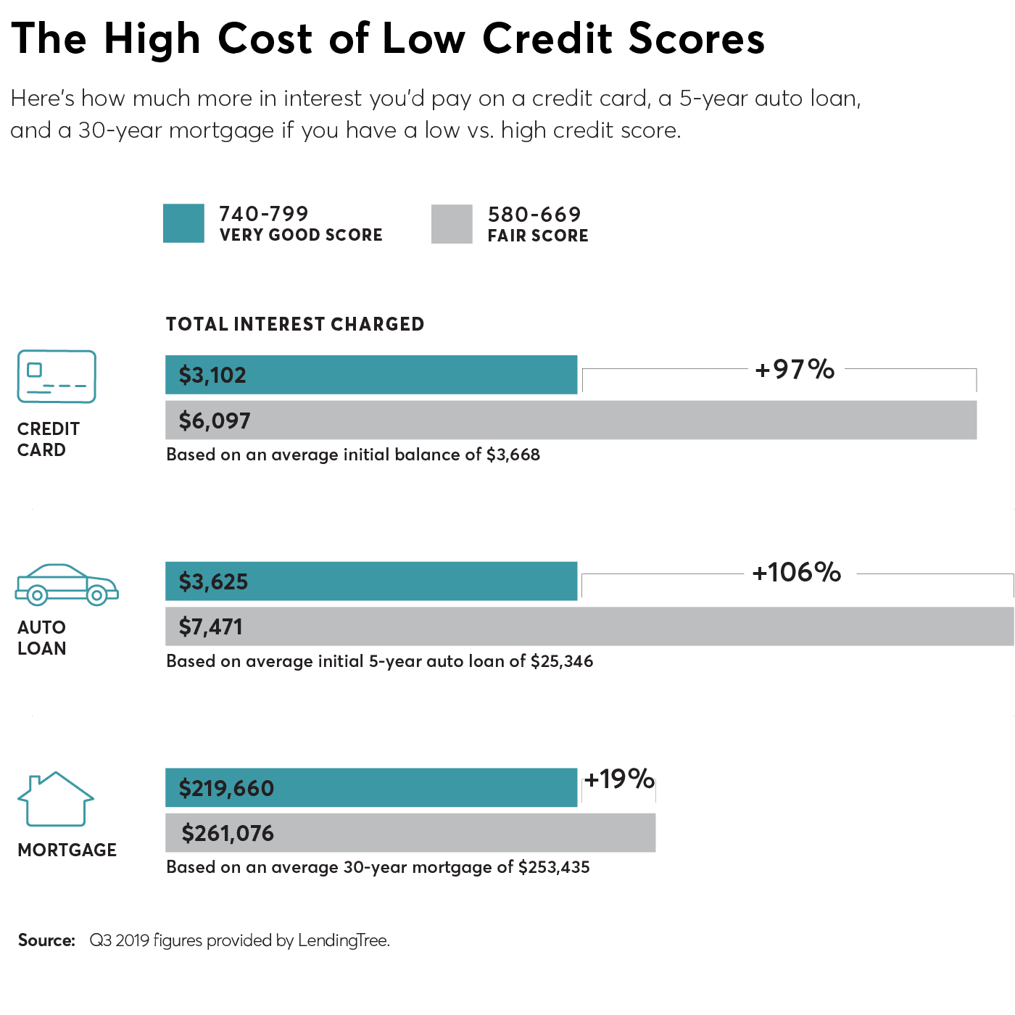

How to Build Credit Fast
Fix 1
Open a bank account, then take out a really small loan and make monthly payments. That’s how Williams fixed her credit. She took out several small loans from a credit-builder loan program that doesn’t require a credit score offered at Hope Credit Union, which serves economically distressed communities in the South. Williams paid back the loans, dramatically improving her credit score.
You may be able to get a loan more easily at a credit union than at a bank, says Felicia Lyles, a senior vice president at Hope. That’s because credit unions are nonprofits, owned by their members, and often offer better terms. Credit unions may also let you use your paycheck to secure the loan to build a payment history, for instance.
Fix 2
Apply for a secured credit card. This is a type of credit card that you’ve backed with a cash deposit. The amount you put in becomes your credit limit. By using the card and paying it off over time, you will start to build your history and improve your score, Hardekopf says. Check that the bank or credit union backing the card reports your payment activity to all three credit bureaus. Learn the terms and conditions. And don’t sign up for a card advertised in grocery or other stores; those cards may carry big fees.
Fix 3
Ask a family member or trusted friend with good credit to add you as a user on their credit card. The debt paid off on the card will show up on your credit report and help your score, Hardekopf says. But make this move only with people you trust and have an existing financial relationship with because if they miss or are late with a payment, it can ding your score as well as theirs.
Fix 4
Opt in to Experian Boost free of charge to get on-time utility, cell, and even Netflix payments counted toward your credit score. Get your rent counted, too, by signing up, along with your landlord, for a service like RentTrack or PayYourRent. For a fee, these programs link your bank account with your credit report to capture nontraditional types of bill paying. They are indicators that a consumer who is “credit invisible” or has a thin credit file is able to manage credit responsibly, says Francis Creighton, president and CEO of the Consumer Data Industry Association, the trade group that represents the credit bureaus.
Go to experian.com to sign up for Experian Boost. Although the program “might increase your score by just a few points,” Hardekopf says, that could be enough to move your ratings from “fair” to “good.”

Problem: So Many Scores
Equifax, TransUnion, and Experian make money by selling credit reports and scores, based on models developed by FICO and VantageScore, to banks, insurers, credit card companies, even employers and marketing firms. That’s why you have not one but many credit scores, each designed to assess risk for these various businesses.
For example, when you apply for a mortgage, your lender is most likely to use FICO 2, 4, or 5. But many consumers are surprised to learn that those mortgage scores tend to be lower than other credit scores, says CR’s Ejaz.
That’s because mortgage FICO scores weigh on-time payments more heavily than FICO 8 or similar scores, which are used by auto lenders and credit card companies.
The 4 Credit Scores You Must Know About

Lenders use different scores depending on whether you’re seeking a loan for a house, car, or credit card. Here are common ones.

GENERAL CREDIT

Type of score: FICO 8, 9. VantageScore 3.0.

Find it: Free through many banks, credit card issuers, and websites

MORTGAGE

Type of score: FICO 2, 4, 5

Find it: Free in mortgage documents or starting at $19.95 at myfico.com

AUTO LOAN

Type of score: FICO Auto Score 2, 4, 5, 8

Find it: Starting at $19.95 at myfico.com

CREDIT CARD

Type of score: FICO Bankcard Score 2, 3, 4, 5, 8

Find it: Starting at $19.95 at myfico.com

How to Manage Multiple Scores
Fix 5
If you’re seeking a loan, ask the lender which VantageScore or FICO score it uses. Then find out how you perform on that score. (Go to myFico for your FICO score, or to a third party such as American Express or NerdWallet for your VantageScore. You may have to pay to see the scores—$30 for FICO’s Advanced subscription plan, which lets you see scores from all three bureaus.)
If you can learn the main factors that a score considers, you may be able to boost it, Hardekopf says. For example, you could pay down credit card debt to improve your debt-to-credit ratio, which is likely to improve some scores.
Fix 6
Check your credit report, and dispute any errors you find. Obtain your credit report free of charge at AnnualCreditReport.com and read it carefully. All credit scores can benefit from having incorrect negative items removed, Ejaz says.
In CR’s recent study, "A Broken System: How The Credit Reporting System Fails Consumers and What to Do About It," of the 34 percent of volunteers who found errors, 11 percent said they were related to debt they didn’t owe or had already paid off, or to payments inaccurately reported as late or missed.
Dispute errors in writing by sending a certified letter with supporting evidence to each of the big three credit bureaus. They have about 30 days to respond.
Fix 7
Pay down credit card debt so that you use no more than 30 percent of your available credit. All credit scores respond to the same good habits, and lenders like to see that you have available credit but aren’t using much of it, says Bruce McClary, a senior vice president for the National Foundation for Credit Counseling, an organization that helps consumers improve their financial profile. Reducing debt load will almost always help scores.

Problem: Small Slip-Ups Cause Big Problems
Debts 30 days or more past due can devastate your credit history and score, and the impact can be long-lasting.
Patricia L. of Allen, Texas (who asked that her last name be withheld), found that her credit score plummeted more than 140 points after an electric bill for less than $100 went unpaid because it was sent to the wrong address. The bill went to collections, which she discovered when a credit monitoring service she uses alerted her to the lower score.
By then it was too late. “Credit collection agencies should notify you before an item gets put on your credit report,” she says.
Something similar happened to Robin Hennessy from CR’s consumer panel. She says her “exceptional” score dropped 100 points after a single missed payment on a credit card. The mistake still haunts her report even though it happened three years ago.
Indeed, such payment snafus can stay on your report for seven years—a period set in the 1970 Fair Credit Reporting Act. But that is “arbitrary,” says Wu at the National Consumer Law Center. She says that Sweden and Germany keep negative items on credit reports for three to four years. Doing the same in the U.S. could “minimize the vicious cycle aspect of low credit scores,” she says.

Improving Your Numbers
Fix 8
Pay off debts in collections as soon as possible. Collections debt is treated differently from late payments, and once it is paid, most credit-scoring systems won’t include it in their calculation or weigh it as heavily, McClary says. If you’re negotiating with a debt collector, ask that the notice be removed from your report once the debt is paid. The collector may do so. “There is no law that says the collection agency has to report it,” he says.
Fix 9
When mortgage shopping, do it within a month. Each time a mortgage lender looks up your credit, called a “hard pull,” it hurts your score by a few points for a year or two, McClary says. Credit bureaus usually consolidate similar hard pulls for mortgages, so a good rule of thumb is to do your comparison shopping within 30 days.
Fix 10
Be careful when shopping for credit cards, too. Ironically, potential lenders “don’t want to see that you’re shopping around for credit,” McClary says, because it looks like you’ve met financial trouble. So don’t apply for a card unless you’re sure you qualify and you’ve settled on a card you want, he says.
Fix 11
Avoid closing unused credit accounts. You may assume there’s no reason not to cancel a card you never use. But doing so could drag down your score, McClary says, if it changes your debt-to-credit ratio. That’s what happened to Terry Wilson, who lived in Pennsylvania when a Capital One account he no longer used was closed by the bank. “The loss of a $15,000 line of credit plunged my credit score,” he says.
Exception: It can make sense to close a card with a high annual fee or if doing so will help you control spending.
Editor’s Note: This article also appeared in the July 2021 issue of Consumer Reports magazine.

Did you check your credit report and find errors? If so, what was your experience?
In the wake of the pandemic, more people than ever are reporting errors on their credit reports. Mistakes can be as common as a misspelled name to paid-off accounts showing as unpaid. And these errors can have a huge impact on your credit score, costing you real money.
Consumer Reports’ Credit Check-Up is a people-powered research project where thousands of consumers told us about errors in their credit reports to help hold credit agencies accountable.
You can do even more by answering a few simple questions:
Did you find errors in your credit report, and did you take steps to dispute these errors and correct them? If so, what was your experience? Were you able to get a resolution?
Your response will help our work reforming how the major credit reporting companies — Equifax, Experian, and TransUnion — do business.

Why Mortgage Credit Scores Are Little Known and Often Low

Credit Bureaus Extend Weekly Free Credit Reports Until 2022

