Casella raises 33K for Habitat for Humanity to build home for Syrian family
- By Kate Barcellos Staff Writer Jul 29, 2019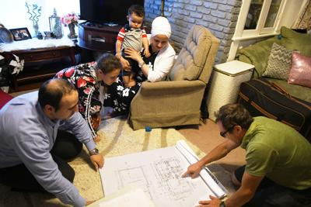
Eric Solsaa, right, shows the family the proposed plans for their Habitat for Humanity house for the first time last month in Rutland. Hussam Alhallak is at left with his family.
Robert Layman / Staff File Photo
Several weeks ago, Habitat for Humanity was still $35,000 away from building a house for Hussam Alhallak his wife Hazar Mansour and their three children on Crescent Street.
But when the Rutland Herald published an article about the family, their journey from Syria, and their tireless efforts to make a life for their family in America, Alhallak’s coworkers at Casella Waste Management, where he works as an accountant, banded together and raised $16,495 for the family to donate toward their building costs.
But Casella wasn’t done yet: Jeff Weld, director of community engagement at Casella Waste Systems, said the company pledged to match employee fundraising, which brought the total donated by Casella and Casella employees to $32,990.
When he was informed on Monday evening, Alhallak was ecstatic.
“They’re very great people,” Alhallak said of his coworkers at Casella. “Thank you very much for everybody, and especially all the group at Casella. My owner, John, and everyone. It’s great news! I am very happy, thank God. It’s great news.”
The construction on the new home began a week and a half ago, Solsaa said, and Alhallak said he was honored to work alongside them creating the foundation.
Weld said once the story was out, the entire company at Casella rose to support Alhallak and his family, and many inquired as to how they could be more directly involved with the project by volunteering on the site.
“Everyone thinks the world of Hussam,” Weld said. “(With) two company-wide emails, we raised almost $17,000.”
A ground-breaking event is planned for Sunday, Aug. 4, at 1 p.m. On the site, and Solsaa said they hope to have the home finished and move-in ready by March.
“The idea is for people to come out and meet the volunteers and the family and the building community,” Solsaa said.
The home will have four bedrooms with an open living room and kitchen, one and a half bathrooms and two rooms upstairs, all surrounded by vinyl siding.
The structure will cost an estimated $120,000 to build, which Alhallak and his family will pay back to Habitat through a no-interest loan, Solsaa said.
Alhallak and his family moved first to Turkey, and then to the United States where they settled in Rutland after being relocated to their original destination in Los Angeles.
Their current apartment up the road on Crescent Street is neatly decorated with sequined pillows, with gleaming surfaces and smelling of rich, dark coffee and cardamom.
But their kitchen is so small they cannot eat together, and five people live in an apartment built for two at the most. The couple had their youngest, Danyal, just 14 months ago.
“When we found out (about the Habitat for Humanity house),” Alhallak said of their initial acceptance as H4H’s next family, “It was like flying!”
Though the fundraising efforts to build the home have pulled off, Solsaa said Habitat is still stretched thin and are looking forward to welcoming volunteers — who can show up at any time on-site or to help behind the scenes — to their newest project.
And their next project is soon to be on its way — Solsaa said Habitat is looking for its next applicant to be able to begin designing and building in the spring, and anyone is welcome to apply.
katelyn.barcellos @rutlandherald.com katelyn.barcellos@rutlandherald.com

